Course ID: BIT 112
Course Name: BCA
Program: BIT FALL 2019

Semester: 1 Year/ I semester


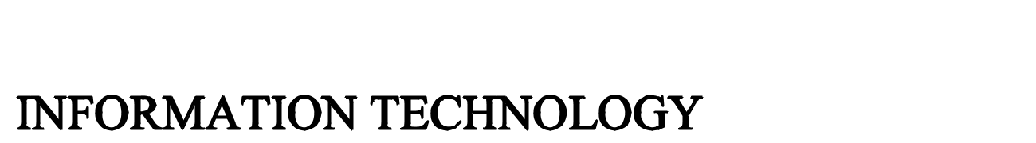

BACHELOR IN INFORMATION TECHNOLOGY

ASSIGNMENT

Submitted by:

Submitted to:

Name: Lincoln University

Date: 2020.06.03

Page 1

Course ID: BIT 112
Course Name: BCA
Program: BIT FALL 2019

Semester: 1 Year/ I semester

1. What is k- map? Why it is used? Explain k-map with examples.

- K- map is the graphical representation of given expression which can be simplification of Boolean Algebra. We can construct k-map using 2, 3, 4 variables and so on. K-map stands for Karnaugh Map which was introduced in 1953 by Maurice Karnaugh.

K-map is used:

  - It’s simplification technique is simpler and less error compared to the method of solving logical expression using Boolean Law.

  - No need to remember each and every Boolean Algebric Theorem.

  - For the simplified expression fewer steps are used instead than the Algebric minimization technique.

  - Minimum expression result can be carried out by this simplification technique.

For Example:

SOP:

 |  | B
A |  |  |  |  |  | 0 B |  |  |  |  | 1B
 | A |  | 0 |  |  | A.B |  |  |  |  | A.B
 | A |  | 1
 |  |  |  | A.B |  |  |  |  |  | A.B
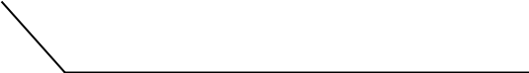

2. What is an expansion slot? Explain its types?

- An expansion slot is a motherboard socket that is used to insert an expansion card (or circuit board) that provides additional features such as video, sound, advanced graphics, Ethernet, or memory to a computer.

Its types are:

  - ISA slot: ISA’s full form is Industry Standard Architecture and a 16- bit bus. These were the oldest slots for expansion in motherboard history. They have been found in AT boards and are marked by color black. Such slots had the installation of traditional show cards or sound cards.

Page 2

Course ID: BIT 112
Course Name: BCA
Program: BIT FALL 2019

Semester: 1 Year/ I semester

  - AGP slot: Special use is made of accelerated graphics port (AGP) to mount a latest graphics card. AGP runs on a 32- bit bus and is able to use both PCL and AGP purchased high end display cards for the games. AGP is an advanced port developed for video cards and is short for accelerated graphics port. AGP implements a dedicated point-to-point channel which allows direct access to device memory by the graphics controller.

  - PCL Slot: PCL in its entire form is peripheral part interconnect. The PCL slot is one of the todays main motherboard components and is widely used to mount motherboard add on cards. The high speed bus supports 64-bits PCL.

  - AMR: AMR is short for audio/ modem riser and enables one card to be made with the modem or audio functionality or both as one card. This design allows the motherboard to be assembled for other external plug-in peripherals at a reduced cost and free up industry standard expression slots inside the device. AMR never achieved widespread acceptance with the modems and sound cards being built into the motherboard, more people using cable, and improved technology like PCL. AMR no longer found nowadays or any new motherboard used. It comes with modem, sound card.
- What is chipset? Explain the Northbridge and Southbridge?

- The chipset is one of the key and most significant components that you find on the motherboard. There were chip for various items, such as chips for bus controllers, memory controllers, keyboard controllers etc. And they had a number of different chips on the motherboard, monitoring various functions. Control of the flow between the CPU, peripherals, bus slots, and memory is the task. Chipsets may contain instructions for controlling CPU, PCL, ISA or USB hardware. A recent Intel chipset such as the i820 or the Intel 820 Chipsets is an example.

Northbridge: The Northbridge links the Southbridge to the CPU and is commonly referred to as the core for the memory power. The Northbridge manages the faster interaction requirements of a computer, and controls connectivity between the CPU, RAM, ROM, BIOS, accelerated graphics port (AGP) and chip Southbridge. The Northbridge directly connects I/O signals to the CPU. The CPU uses the Northbridge frequency as a baseline for determining the frequency of its operation.

Page 3

Course ID: BIT 112
Course Name: BCA
Program: BIT FALL 2019

Semester: 1 Year/ I semester

Southbridge: The Southbridge, responsible for the hard drive controller, the I/O controller and the integrated hardware, is on the motherboard. It is also known as the Input/ Output controller core and is not directly connected to the CPU. Southbridge manages slower connections for the motherboard, including tools for input/ output (I/O) and computer peripherals such as expansion slots and hard disk drivers.

4. What is BIOS? Explain its functions.

- BIOS in computer form is the simple input output method. It is a component of the motherboard, as an integrated chip. Unlike your operating system (which is stored on your hard drive), the Bios for your computer is stored on your motherboard on a disk. This chip contains all the motherboard information and setting which can be modified by entering your computer’s BIOS mode. The BIOS is a

ROM chip found on the motherboard that allows you to access and customize the most basic level of your computer system.

Its functions are:

- POST: Check the computer hardware before loading the operating system, to make sure there are no errors. POST, short for power on self check, is the computer’s initial series of diagnostic checks right after it’s turned on, with the purpose of testing for any hardware related issues.

- Bootstrap loader: The operating system is installed. If there is capable operating system, the BIOS must transfer power to that system.

- BIOS drivers: Low-level drivers which give the computer basic operational control over the hardware of your computer.

- BIOS or CMOS setup: Configuration software which allows you to configure hardware setting including device setting including machine passwords, time, and data.

- Explain the different types of logic gates with its logic diagram and truth table.
  - The different types of logic gates are as follows:

    - AND Gate: A circuit which performs an AND operation. It has n input and one output.

Y= A AND B AND C……N Y= A.B.C………N

Page 4

 | Course ID: BIT 112 |  |  |  |  | Course Name: BCA
 |  |  |  |  |  | Program: BIT FALL 2019
 |  |  |  |  |  | Semester: 1 Year/ I semester
 | Logic Diagram
 | A |  |  |  |  | Y
 | B
 | Truth Table
 | Inputs |  |  |  |  |  | Outputs
 | A |  |  |  | B |  | A.B
 | 0 |  |  |  | 0 |  | 0
 | 0 |  |  |  | 1 |  | 0
 | 1 |  |  |  | 0 |  | 0
 | 1 |  |  |  | 1 |  | 1
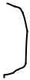

• OR gate: A circuit which performs an OR operation. It has n input and one output.

Y= A OR B OR C…..N

 |  |  |  | Y= A+B+C+……….N
 |  |  |  | A |  |  |  | Y
 |  |  |  | B
 | Truth Table:
 | Inputs |  |  |  |  |  |  | Outputs
 | A |  |  | B |  |  |  | A+B
 | 0 |  |  | 0 |  |  |  | 0
 | 0 |  |  | 1 |  |  |  | 1
 | 1 |  |  | 0 |  |  |  | 1
 | 1 |  |  | 1 |  |  |  | 1
 |  |  |  |  |  |  |  |  | Page 5
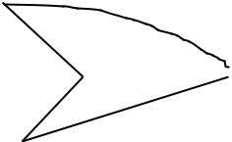

Course ID: BIT 112
Course Name: BCA
Program: BIT FALL 2019

Semester: 1 Year/ I semester

- NOT Gate: NOT Gate is also known as Inverter. It has one input A and one output

- Y. Y= NOT A

- Y= A

Logic Diagram
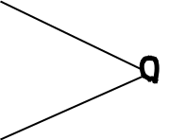

A |  | Y

Truth Table

Inputs |  |  | Outputs
A |  |  | A
0 |  | 1
1 |  | 0
 | • NAND Gate: A NOT-AND operation is known as
 | NAND operation. It has n input and one output.
 | • Y= A NOT AND B NOT AND C…….N
 | • Y= A NAND B NAND C……N

Logic Diagram

A
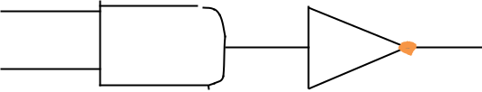

Y

B

Page 6

Course ID: BIT 112 |  | Course Name: BCA
 |  | Program: BIT FALL 2019
 |  | Semester: 1 Year/ I semester
Truth Table
Inputs |  |  |  | Outputs
A | B |  |  | AB
0 | 0 |  | 1
0 | 1 |  | 1
1 | 0 |  | 1
1 | 1 |  | 0

• NOR Gate: A NOT-OR operation is known as NOR operation. It has n inputs and one output. Y= A NOT OR B NOT OR C……N Y= A NOR B NOR C…..N

Logic Diagram

A

 |  |  |  |  |  |  |  | Y
 | B
Truth Table
Inputs |  |  |  |  |  |  | Outputs
A |  |  | B |  |  |  | A+B
0 |  |  | 0 |  |  |  | 1
0 |  |  | 1 |  |  |  | 0
1 |  |  | 0 |  |  |  | 0
1 |  |  | 1 |  |  |  | 0
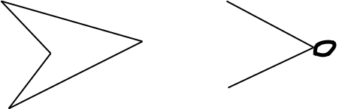

• XOR Gate: XOR or EX-OR gate is special type of gate. It can be used in the half adder, full adder and subtractor. The exclusive OR gate is abbreviated as EXOR gate or sometimes as X-OR gate. It has n inputs and one output.

Page 7
Course ID: BIT 112 |  |  |  |  | Course Name: BCA
 |  |  |  |  | Program: BIT FALL 2019
 |  |  |  |  | Semester: 1 Year/ I semester
Logic Diagram
 |  | A |  |  |  |  | A(+)B
Truth Table |  | B
Inputs |  |  |  |  |  |  | Outputs
A |  |  | B |  |  |  | A(+)B
0 |  |  | 0 |  |  |  | 0
0 |  |  | 1 |  |  |  | 1
1 |  |  | 0 |  |  |  | 1
1 |  |  | 1 |  |  |  | 0
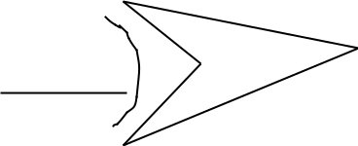

• XNOR Gate: XNOR gate is a special type of gate. It can be used in the half adder, full adder and X-NOR gate. It has n inputs and one output.

Logic Diagram
 |  | A |  |  |  |  |  | Y
 |  |  | B
Truth Table
Inputs |  |  |  |  |  |  | Outputs
A | B |  |  |  |  |  | A(+)B
0 | 0 |  |  |  |  |  | 1
0 | 1 |  |  |  |  |  | 0
1 | 0 |  |  |  |  |  | 0
1 | 1 |  |  |  |  |  | 1
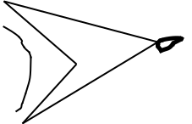

Page 8

